STAR knitting pattern:
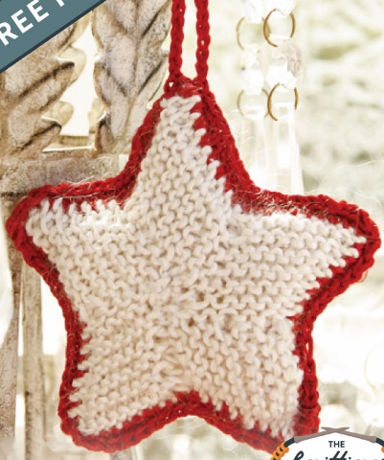
on needle size 2.5 mm (or similar) Work 2 parts in garter st (i.e. K all rows),
Cast on 5 sts
Row 1 (= WS): K all sts - AT THE SAME TIME inc at the end of row - READ INCREASE TIP = 6 sts.
Row 2,4,6,8,10 and 12 (= rows from RS): K all sts.
Row 3: K all sts - AT THE SAME TIME dec at beg of row - READ DECREASE TIP and inc at the end of row = 6 sts.
Row 5, 9 and 13: Work as 1st row (= 1 st inc at the end of row).
Row 7 and 11: Work as 3rd row (= 1 st dec at beg of row and 1 st inc at the end of row). After last inc, there are 9 sts on needle.
Row 14 (= RS): Cast off all sts on row = 1 st remain on row, then knit up 4 sts along the entire left side of piece = 5 sts (NOTE: The last st should be knitted up in 1st row).
Repeat from 1st to 14th row a total of 5 times but the last time work until there are only 9 sts on row (last row = 13th row). On next row, cast off the remaining sts. Sew cast on edge against the left edge of last tip.
Knit another part the same way.
INCREASE TIP:
Inc 1 st at end of row as follows: Make 1 YO before the last st on row. On next row K the YO twisted.
DECREASE TIP:
Dec 1 st at beg of row as follows: K the first 2 sts on row tog.

Blanket stitch the two stars together adding a little stuffing to pad out the star, and add a loop.
or
CROCHET EDGE AND STRAP:
Work the parts tog on hook size 2.5 mm as follows: Place the parts on top of each other, work 1 dc in every st/every other row through both layers along the outer edge - NOTE: Work 2 dc in each tip. Fill some cotton wool when approx. 2 cm remain until 1st dc and finish with 1 sl st in 1st dc. Work 1 more round with 1 dc in every dc (2 dc in each tip), finish with 1 sl st in 1st dc. Then work ch for approx. 12 cm for strap, finish with 1 sl st in 1st dc on 2nd round. Cut and fasten the thread.

Alternative
Needles Required
1 Pair No. 3mm, UK 11 or equivalent
Tension
Knitted in Garter Stitch (every row knit), knitting needs to be reasonably firm.
Pattern
Row : | Instructions
 | Cast on 1 st, leaving a tail long enough to make a hanging loop, if required
1: | K
2-3: | Cast on 1 st and K the row (finish with 3 sts)
4-8: | K
9-10: | Cast on 1 st, K to last 2 sts, M1, K1 (finish with 5 sts)
11-13: | K
14: | Cast on 8 sts and K row (13 sts)
15: | Cast on 7 sts, K to last 2 sts, K2tog (19 sts)
16-17: | S1, K1, psso, K to last 2 sts, K2tog (finish with 15 sts)
18: | K
19-20: | S1, K1, psso, K to last 2 sts, K2tog (finish with 11 sts)
21: | K
22-23: | S1, K1, psso, K to last 2 sts, K2tog (finish with 7 sts)
24: | K1, M1, K to last 2 sts, M1, K1 (9sts)
25-28: | K
29: | Cast on 1 st, K5 (5 sts on RH needle)  Turn the work to only knit on the 5 sts now on the LH needle
30: | S1, K1, psso, K3
31: | K2, K2tog
32: | K
33: | K1, K2tog
34-35: | K
36: | K2tog  Break yarn and pass through remaining st to cast off
 | Join yarn to remaining 5 sts
37: | K2tog, K1, M1, K1
38: | K3, K2tog
39: | S1, K1, psso, K2
40: | K
41: | K2tog, K1
42-43: | K
44: | K2tog  Break yarn and pass through remaining st to cast off
Making Up Sew in all ends and make a hanging loop.

